**Block Diagram:**

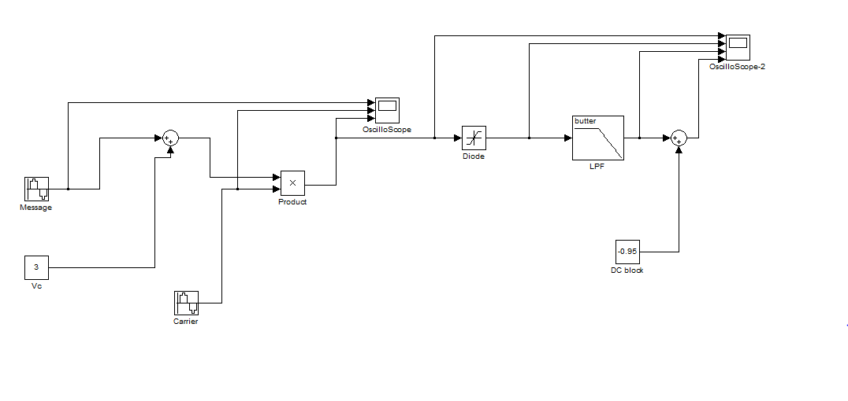

**Fig-01:** Simulink Block Diagram of DSB-FC Modulation & Demodulation

**Modulation Output Waveform:**

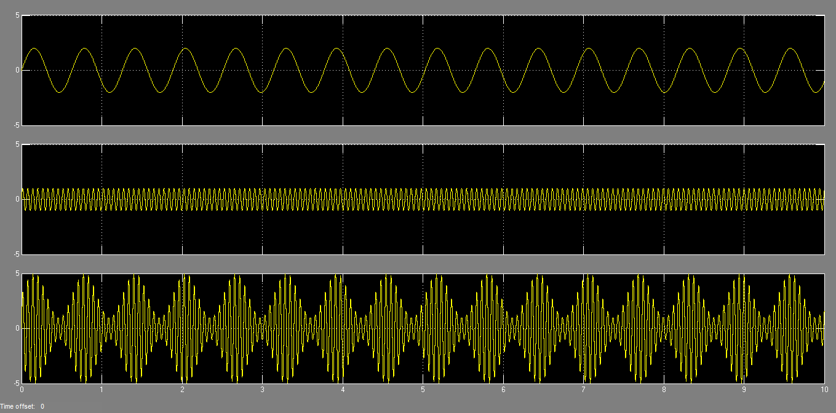

**Fig-02:** Modulation Output for Message Signal Amplitude 2

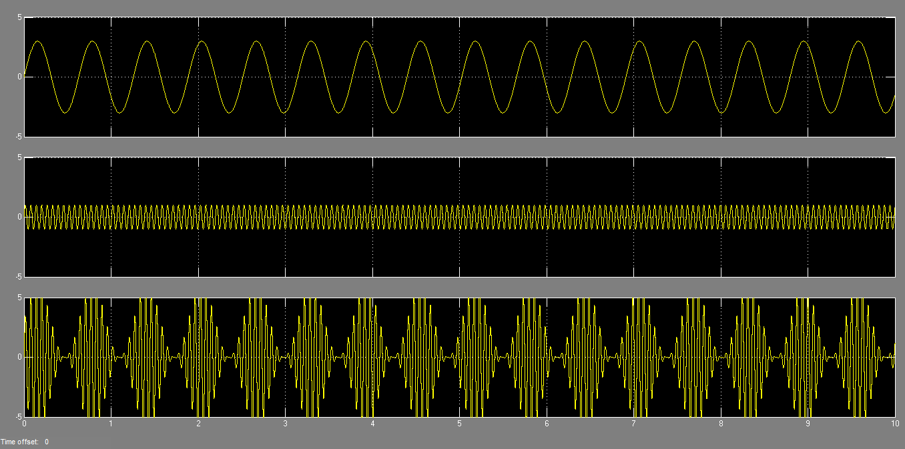

**Fig-03:** Modulation Output for Message Signal Amplitude 3

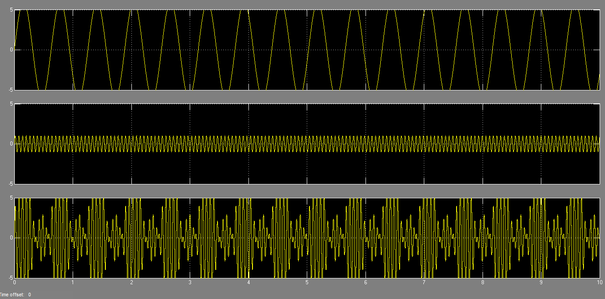

**Fig-04:** Modulation Output for Message Signal Amplitude 6

**Demodulation Output Waveform:**

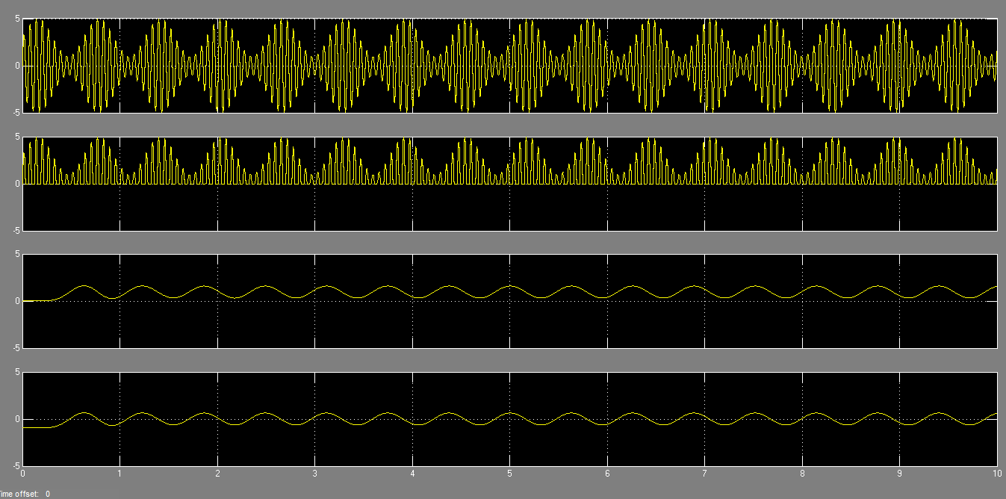

**Fig-05:** Demodulation Output for Message Signal Amplitude 2

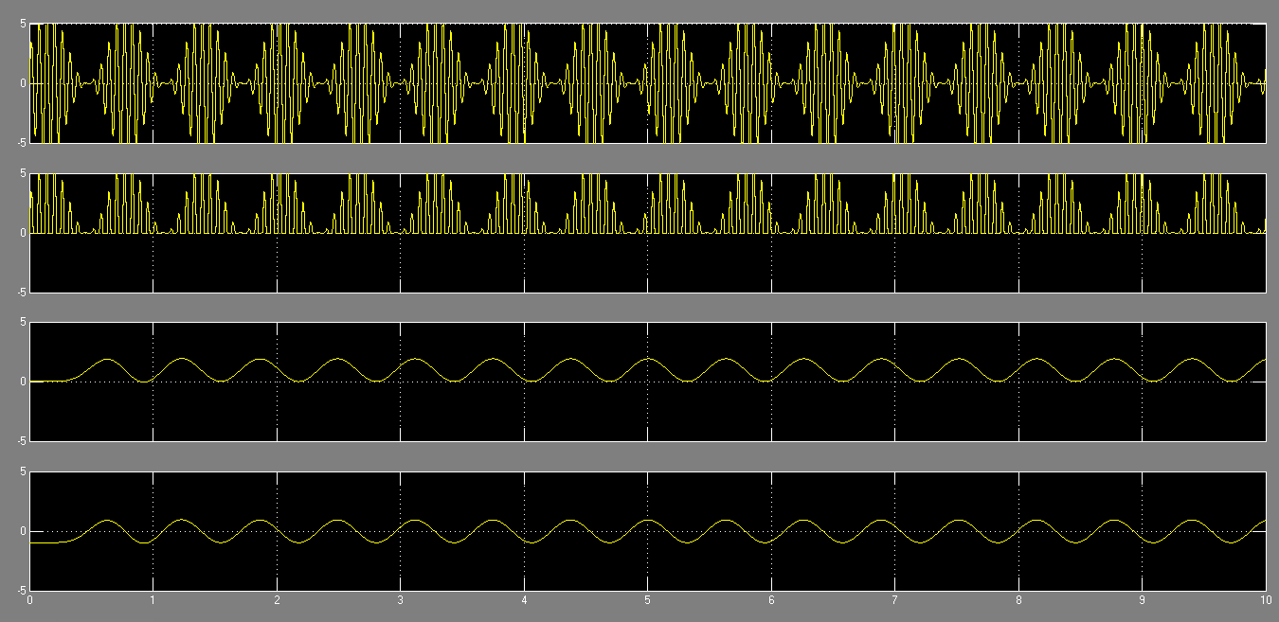

**Fig-06:** Demodulation Output for Message Signal Amplitude 3

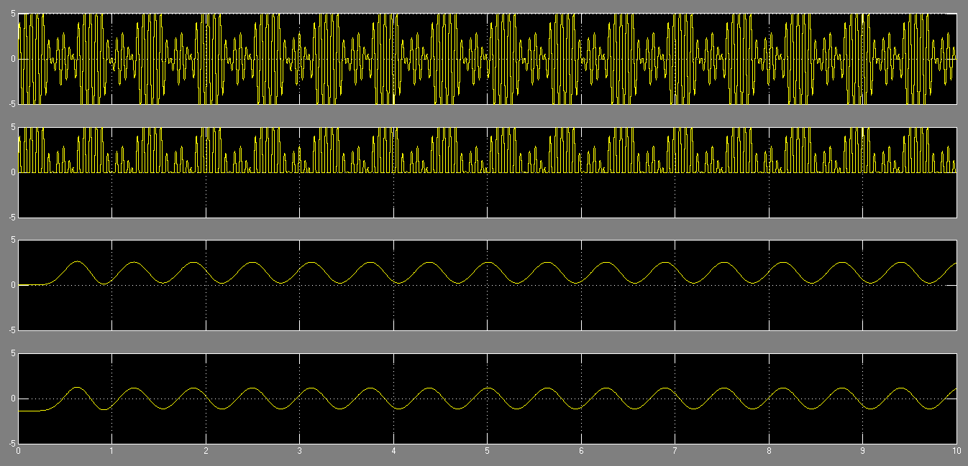

**Fig-07:** Demodulation Output for Message Signal Amplitude 6